SWT 12041 – Practical for Web systems and Technologies
Department of Information and Communication Technology
Faculty of Technology
Labsheet :02
Reg. Number: SEU/IS/20/ICT/084
Academic Year :2020/2021
Date: 2023.02.01
Practical No :02
Title: HTML Tags.

Aims:
• Getting practice to work with some HTML tags.
Task:
• Basic Tags
• List
• Table
• Iframe
• Video
• Audio

Activities:
1. Lists
Ordered Lists
i. Apple
ii. Orange
iii. Mango
iv. Guava
v. Strawberry
<!DOCTYPE html>
<html>
<head>
<title>Order List</title>
</head>
<body>
<h3>Order List</h3>
<ol type="i">
<li>Apple</li>
<li>Orange</li>
<li>Mango</li>
<li>Guava</li>
<li>Strawberry</li>
</ol>
</body>
</html>

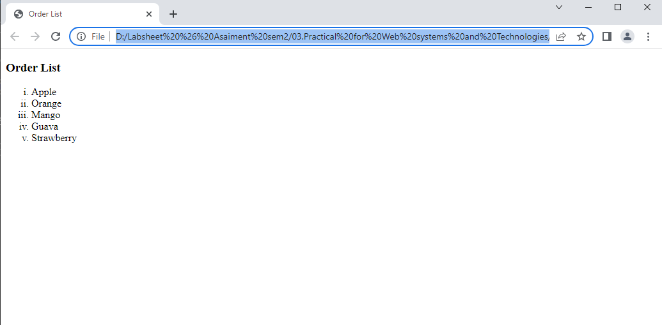
Output:

Unordered List
• Apple
• Orange
• Mango
• Guava
<!DOCTYPE html>
<html>
<head>
<title>UnOrder List</title>
</head>
<body>
<ul>
<li type="none">Unordered List</li>
<ul>
<li>Apple</li>
<li>Orange</li>
<li>Mango</li>
<li>Guava</li>
</ul>
</ul>
</body>
</html>

Output:
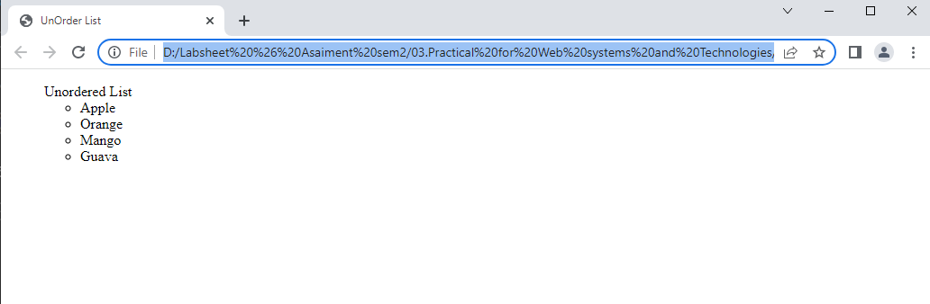

Nested List
o Fruits
▪ Apple
▪ Orange
▪ Mango
▪ Guava
o Vegetables
▪ Carrot
▪ Beans
<!DOCTYPE html>
<html>
<head>
<title>Nested List</title>
</head>
<body>
<h3>Nested List</h3>

<ul>

<li>Fruits</li>
<ul>
<li>Apple</li>
<li>Orange</li>
<li>Mango</li>
</ul>
<li>Guava</li>
<ul>
<li>Vegetables</li>
<li>Carrot</li>
<li>Beans</li>
</ul>

</ul>

</body>
</html>

Output:
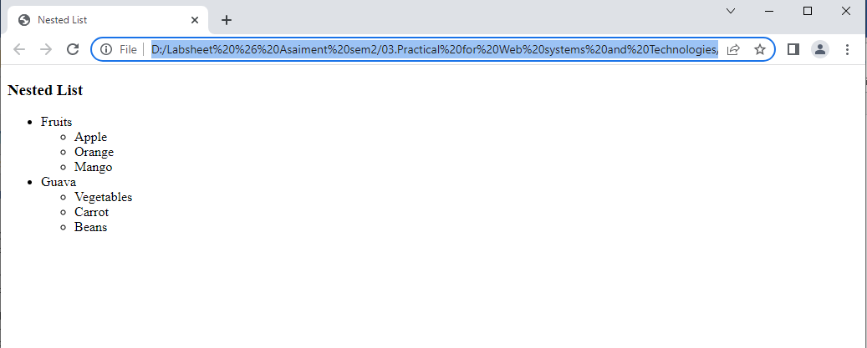

2.Table
a. Simple Table

Reg No | Name | Subject
ICT 123 | Someone | HTML
ICT 234 | Person | JavaScript

<!DOCTYPE html>
<html>
<head>
<title>a. Simple Table</title>
</head>
<body>
<table border="1">
<thead>a.Simple Table</thead>
<tr>
<td>Reg.no</td>
<td>Nname</td>
<td>Subject</td>
</tr>
<tr>
<td>ICT 123</td>
<td>Someone</td>
<td>HTML</td>
</tr>
<tr>
<td>ICT 234</td>
<td>Person</td>
<td>JavaScript</td>
</tr>
</table>
</body>
</html>

Output:
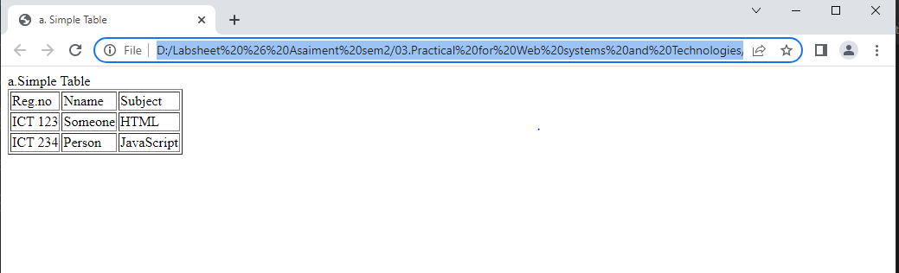

b. Table

Reg No | Name | Subject
ICT 123 | Someone | HTML
ICT 234 | Person | JavaScript

<!DOCTYPE html>
<html>
<head>
<title>Table A</title>
</head>
<body>
<table border="1">
<thead>b.Table</thead>
<tr>
<th>Reg.no</th>
<th>Nname</th>
<th>Subject</th>
</tr>
<tr>
<td>ICT 123</td>
<td>Someone</td>
<td>HTML</td>
</tr>
<tr>
<td>ICT 234</td>
<td>Person</td>
<td>JavaScript</td>
</tr>
</table>
</body>
</html>

Output:

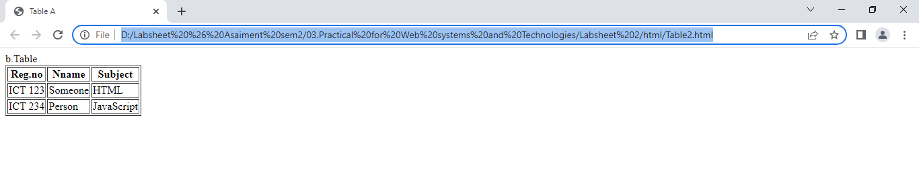

            - c. Merge Table

Reg No | Name | Subject
ICT 123 | Someone | HTML
 |  | JavaScript

<!DOCTYPE html>
<html>
<head>
<title>c. Merge Table</title>
</head>
<body>
<table border="1">
<thead>c. Merge Table</thead>
<tr>
<th>Reg.no</th>
<th>Nname</th>
<th>Subject</th>
</tr>
<tr>
<td rowspan="2">ICT 123</td>
<td rowspan="2">Someone</td>
<td>HTML</td>
</tr>
<tr>
<td>JavaScript</td>
</tr>
</table>
</body>
</html>

Output:
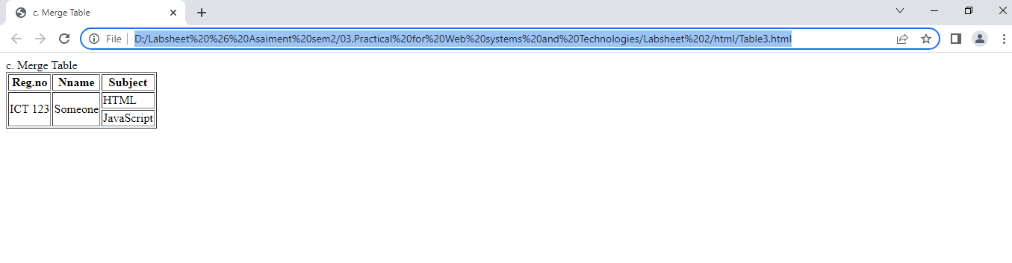
3. Create an iframe with the height 300px and width 600px.
a. Load the http://www.w3schools.com page into your iframe.
b. Set your customized page into iframe.
c. Set the border (Eg: solid 2px solid).
d. Create three html pages and name it as red, green, and blue then change the background color of each pages according the page name.
e. Create 3 links using <a> tag each link should be connect with respective pages then when you click the link the page should be load into iframe.
Main.html
<html>
<head>
<title>EX03_01</title>
</head>
<body>

<iframe src="https://www.w3schools.com/" title="www.w3schools.com" height="300px" width="600px" border: 2px solid black></iframe>

<br>

<a href="red.html" target="myIframe">Red</a>
<a href="green.html" target="myIframe">Green</a>
<a href="blue.html" target="myIframe">Blue</a>

</body>
</html>

green.html
<!DOCTYPE html>
<html>
<head>
<title>Green Page</title>
<style>
body {
background-color: green;
}
</style>
</head>
<body>
<h1>This is the Green Page</h1>
</body>
</html>

red.html
<!DOCTYPE html>
<html>
<head>
<title>Red Page</title>
<style>
body {
background-color: red;
}
</style>
</head>
<body>
<h1>This is the Red Page</h1>
</body>
</html>

blue.html
<!DOCTYPE html>
<html>
<head>
<title>Blue Page</title>
<style>
body {
background-color: blue;
}
</style>
</head>
<body>
<h1>This is the Blue Page</h1>
</body>
</html>

Output:
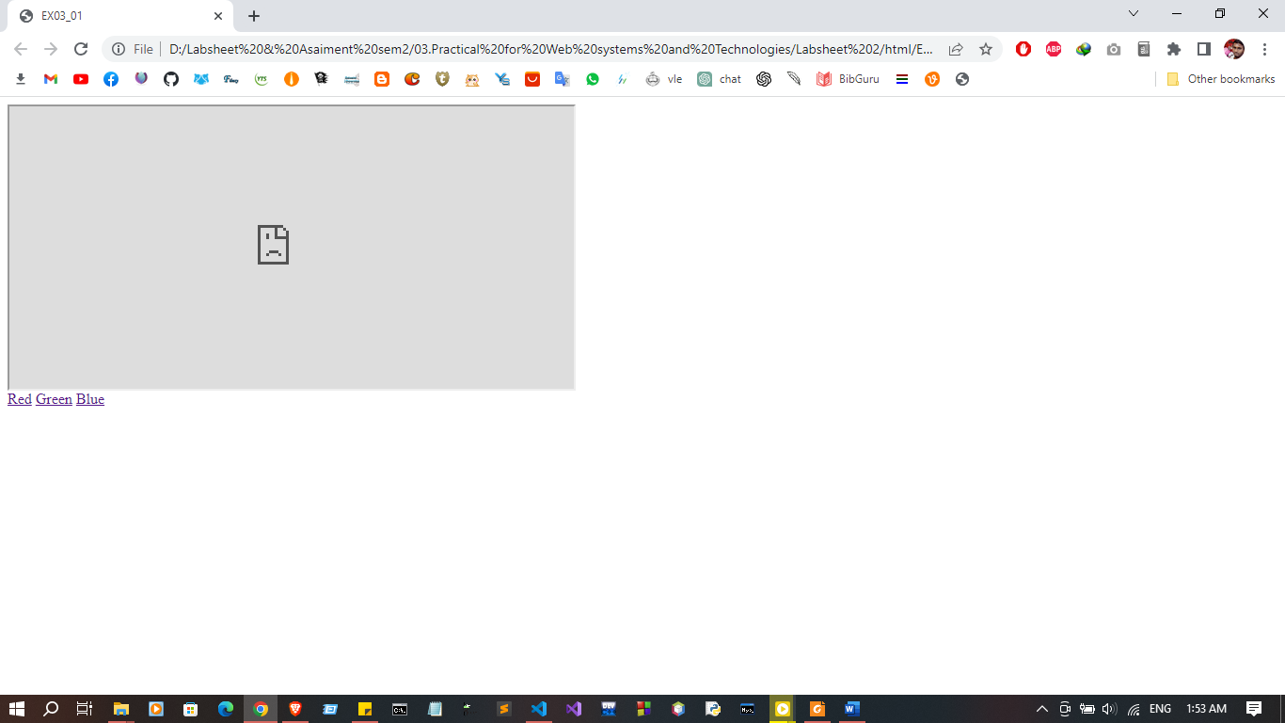
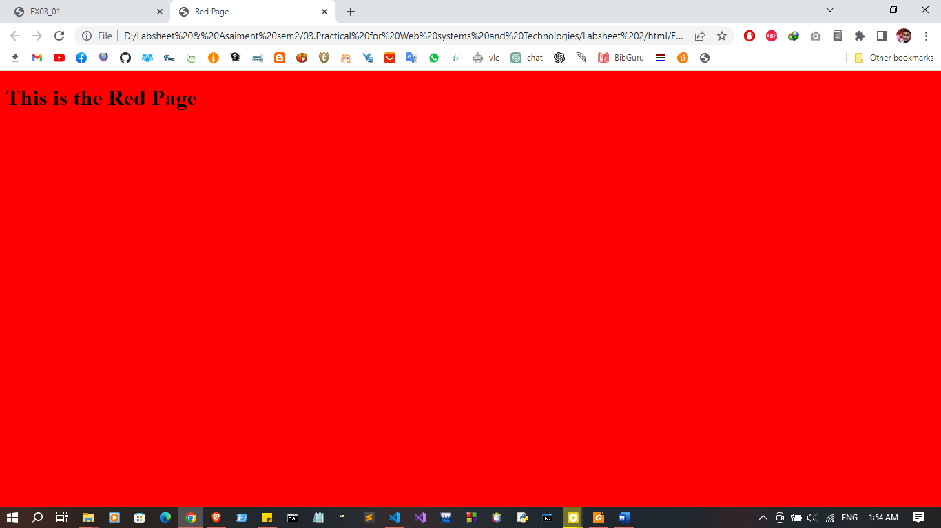
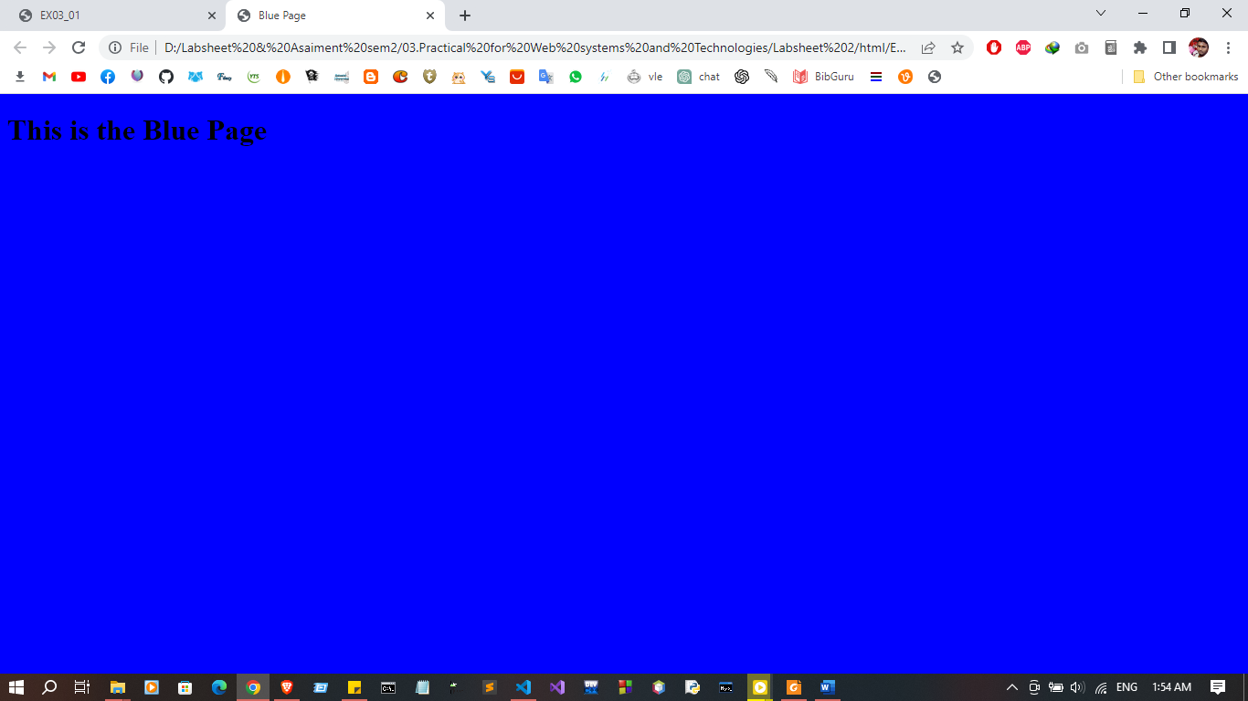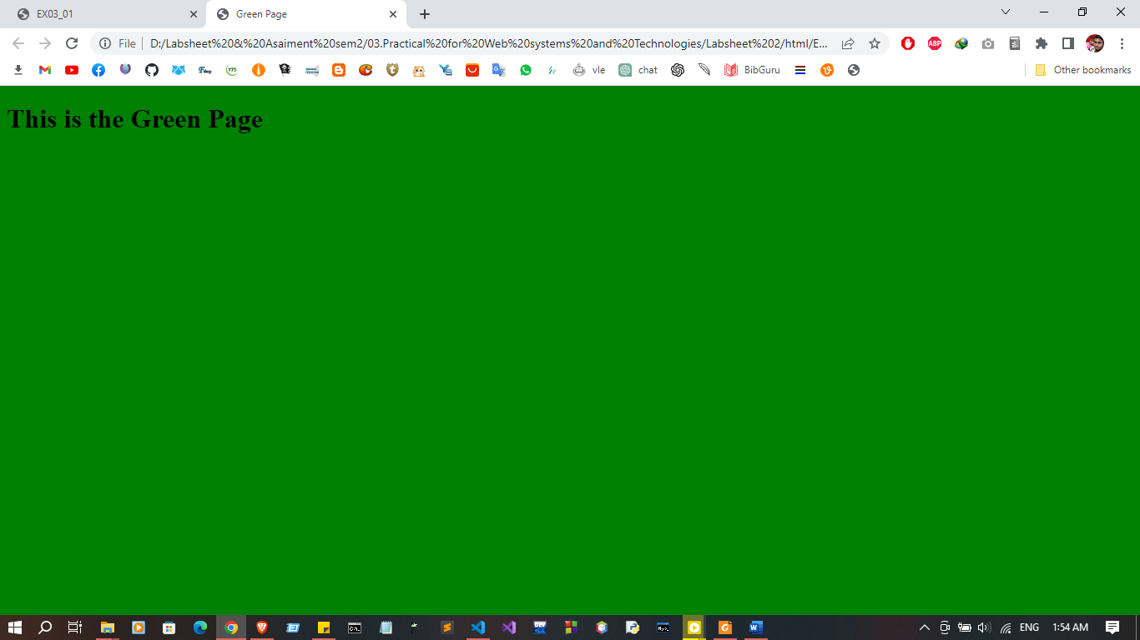

04.Adding a video to the web page.
a. Add a video using <video> tag into your html page.
b. Set the video height into 300px and width 600px.
c. Set additional attributes to the video (Eg: controls, autoplay, src, muted) Video and audio format and type

<!DOCTYPE html>
<html>
<head>
<meta charset="utf-8">
<meta name="viewport" content="width=device-width, initial-scale=1">
<title>EX04</title>
</head>
<body>

<video width="600px" height="300px" autoplay muted>
<source src="videor.mp4" type="video/mp4">
</video>

</body>
</html>
Output:
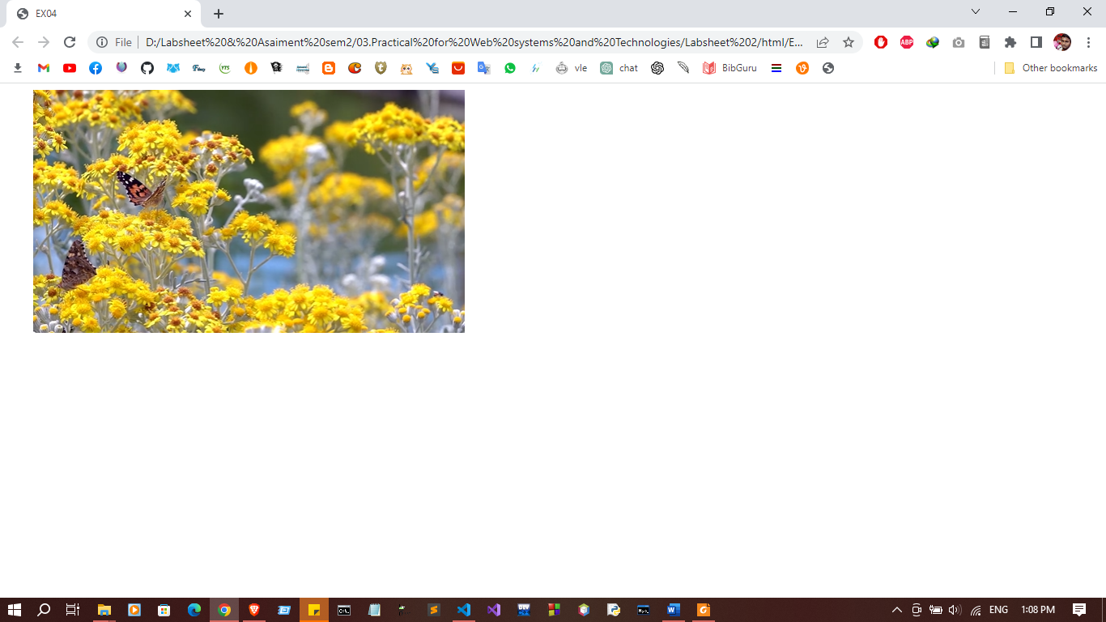
5. Adding an audio to the webpage.
a. Add an audio using <audio> tag into your html page.
b. Set the audio height into 300px and width 600px.
c. Set additional attributes to the audio (Eg: controls, autoplay, src, muted)

<html>
<head>
<title>EX05</title>
</head>
<body>
<audio width="600px" height="300px" controls autoplay muted >

<source src="audio.wav" type="audio/wav">

</audio>
</body>
</html>

Output:
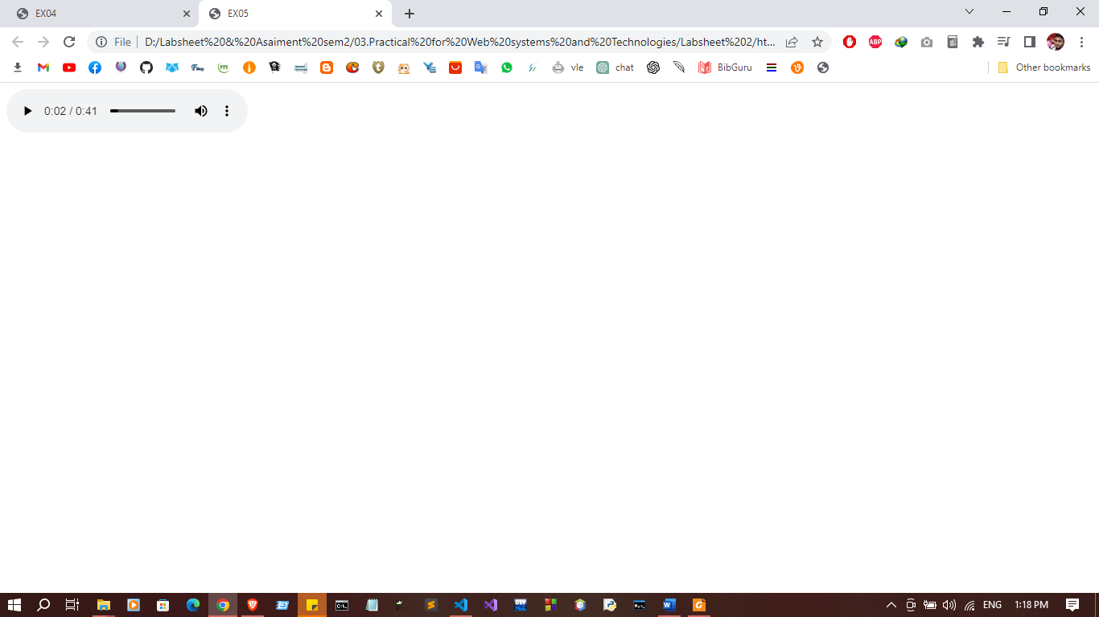

Exersices:
1. Create following Nested List in HTML page
1. Fruits
• Apple
I. Cripps Pink
II. Empire
III. Fuji
2. Orange
• Orange
I. Navel Orange
II. Clementine
III. Tangelo
<html>
<head>
<title>Exersices01</title>
</head>
<body>
<ol type="1">
<li>Appele</li>
<ul>
<li>Apple</li>
<ol type="I">
<li>Cripps Pink</li>
<li>Empire</li>
<li>Fuji</li>
</ol>
</ul>
<li>Orange</li>
<ul>
<li>Orange</li>
<ol type="I">
<li>Navel Orange</li>
<li>Clementine</li>
<li>Tangelo</li>
</ol>
</ul>
</ol>
</body>
</html>

Output:

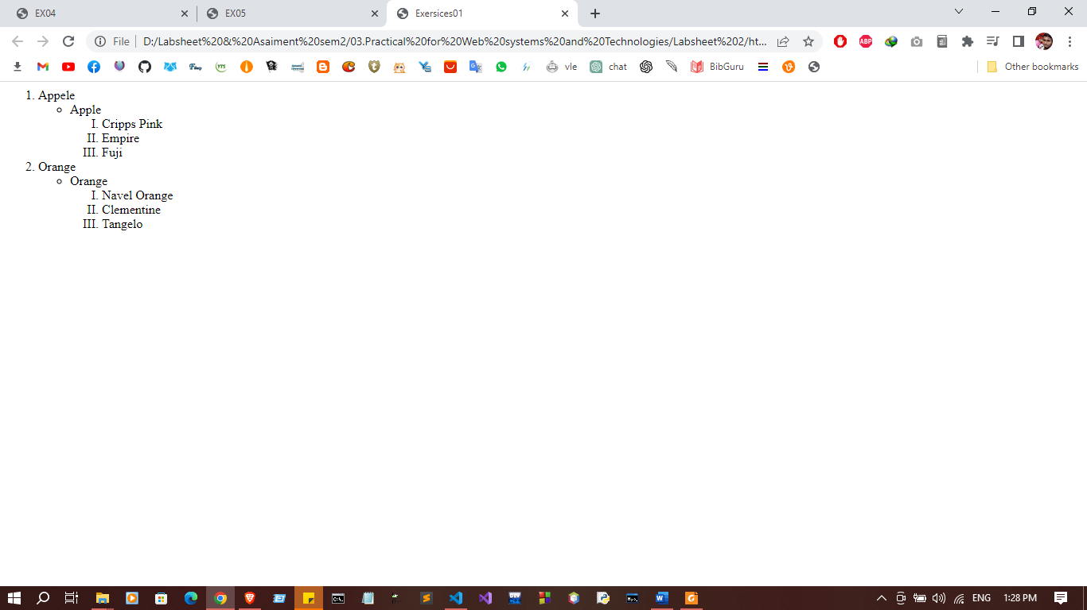

2. Create following Table in HTML page
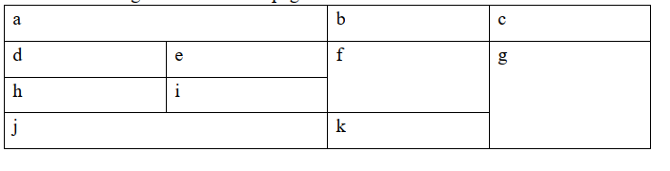
<html>
<head>
<title>Exersices02<</title>
</head>
<body>
<table border="2px" width="50%%" hight="50%">
<tr>
<td colspan="2">a</td>
<td>b</td>
<td>c</td>
</tr>
<tr>
<td >d</td>
<td>e</td>
<td rowspan="2">f</td>
<td rowspan="3">g</td>
</tr>
<tr>
<td >h</td>
<td>i</td>
</tr>
<tr>
<td colspan="2">j</td>
<td>k</td>
</tr>
</table>
</body>
</html>

Output:

